NWJS Norway - August 2022
At the end of the summer Amelia, Peter, Sam & Richard travelled out to Fredrikstad in Norway with 18 other juniors from NWJS. We started with 4 days forest training as well as an evening mass start junior race.
Then there was a rest day combining swimming & beach volleyball.
Some more training on Thursday before a “racing” finish with a long distance tour champs around the SkiHytte, a regional middle race & finally some relays.

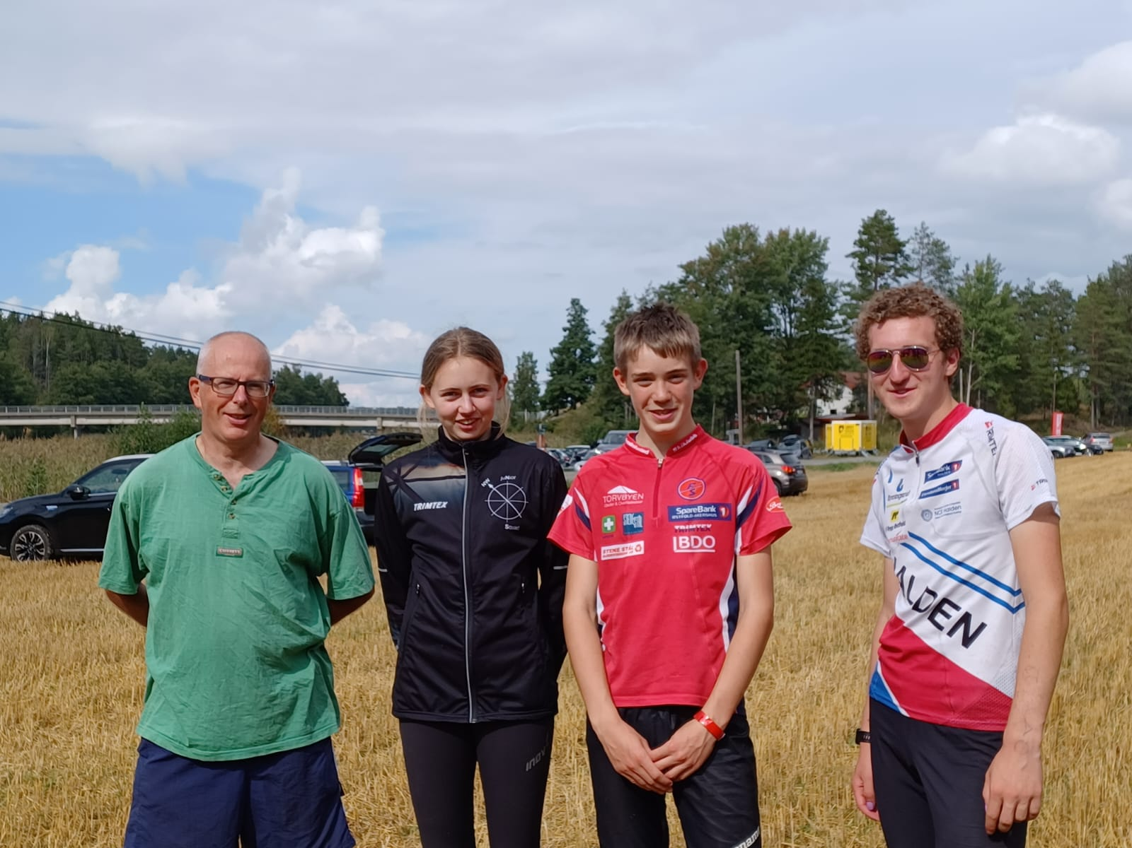
LOC on tour
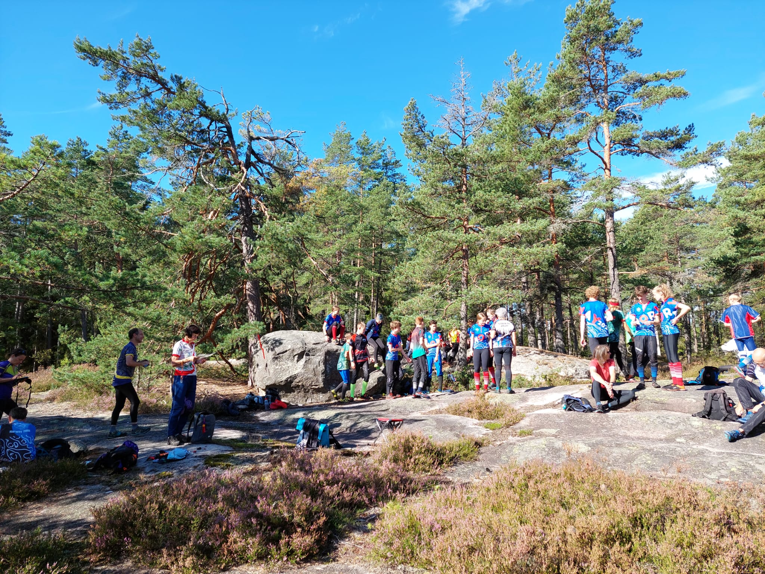
Training close to Fredrikstad SkiHytte
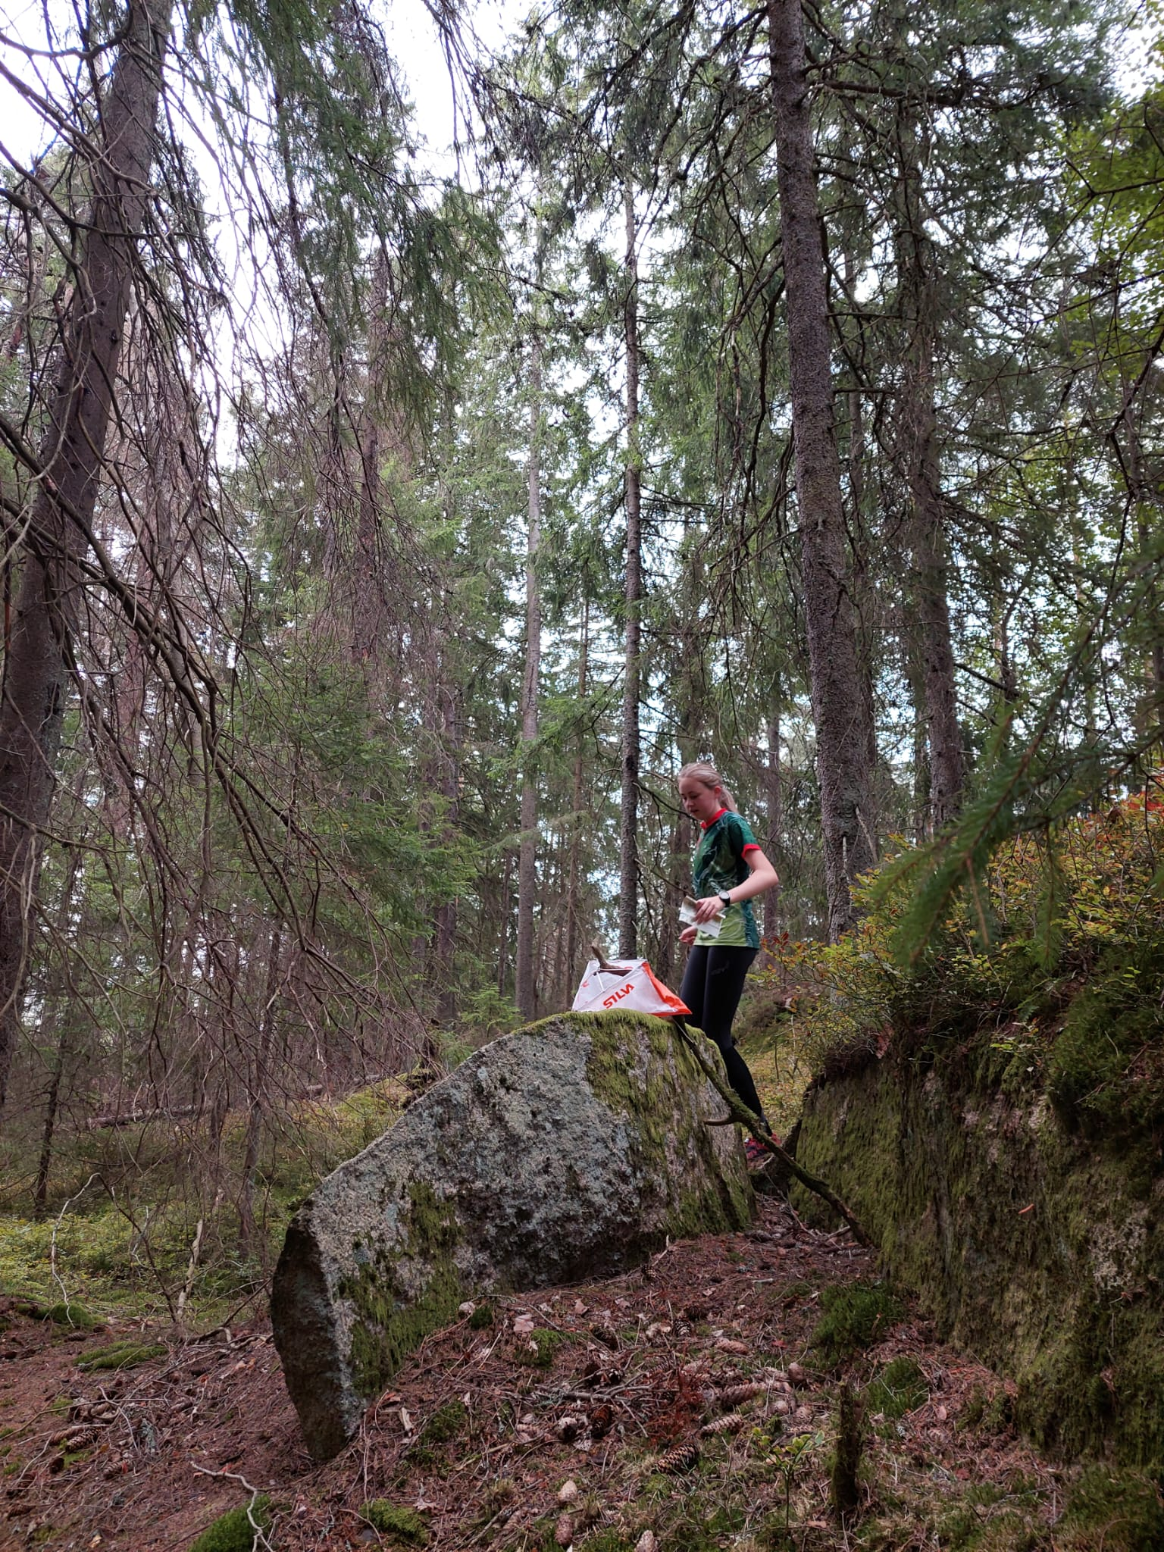
Amelia control #2 tour champs
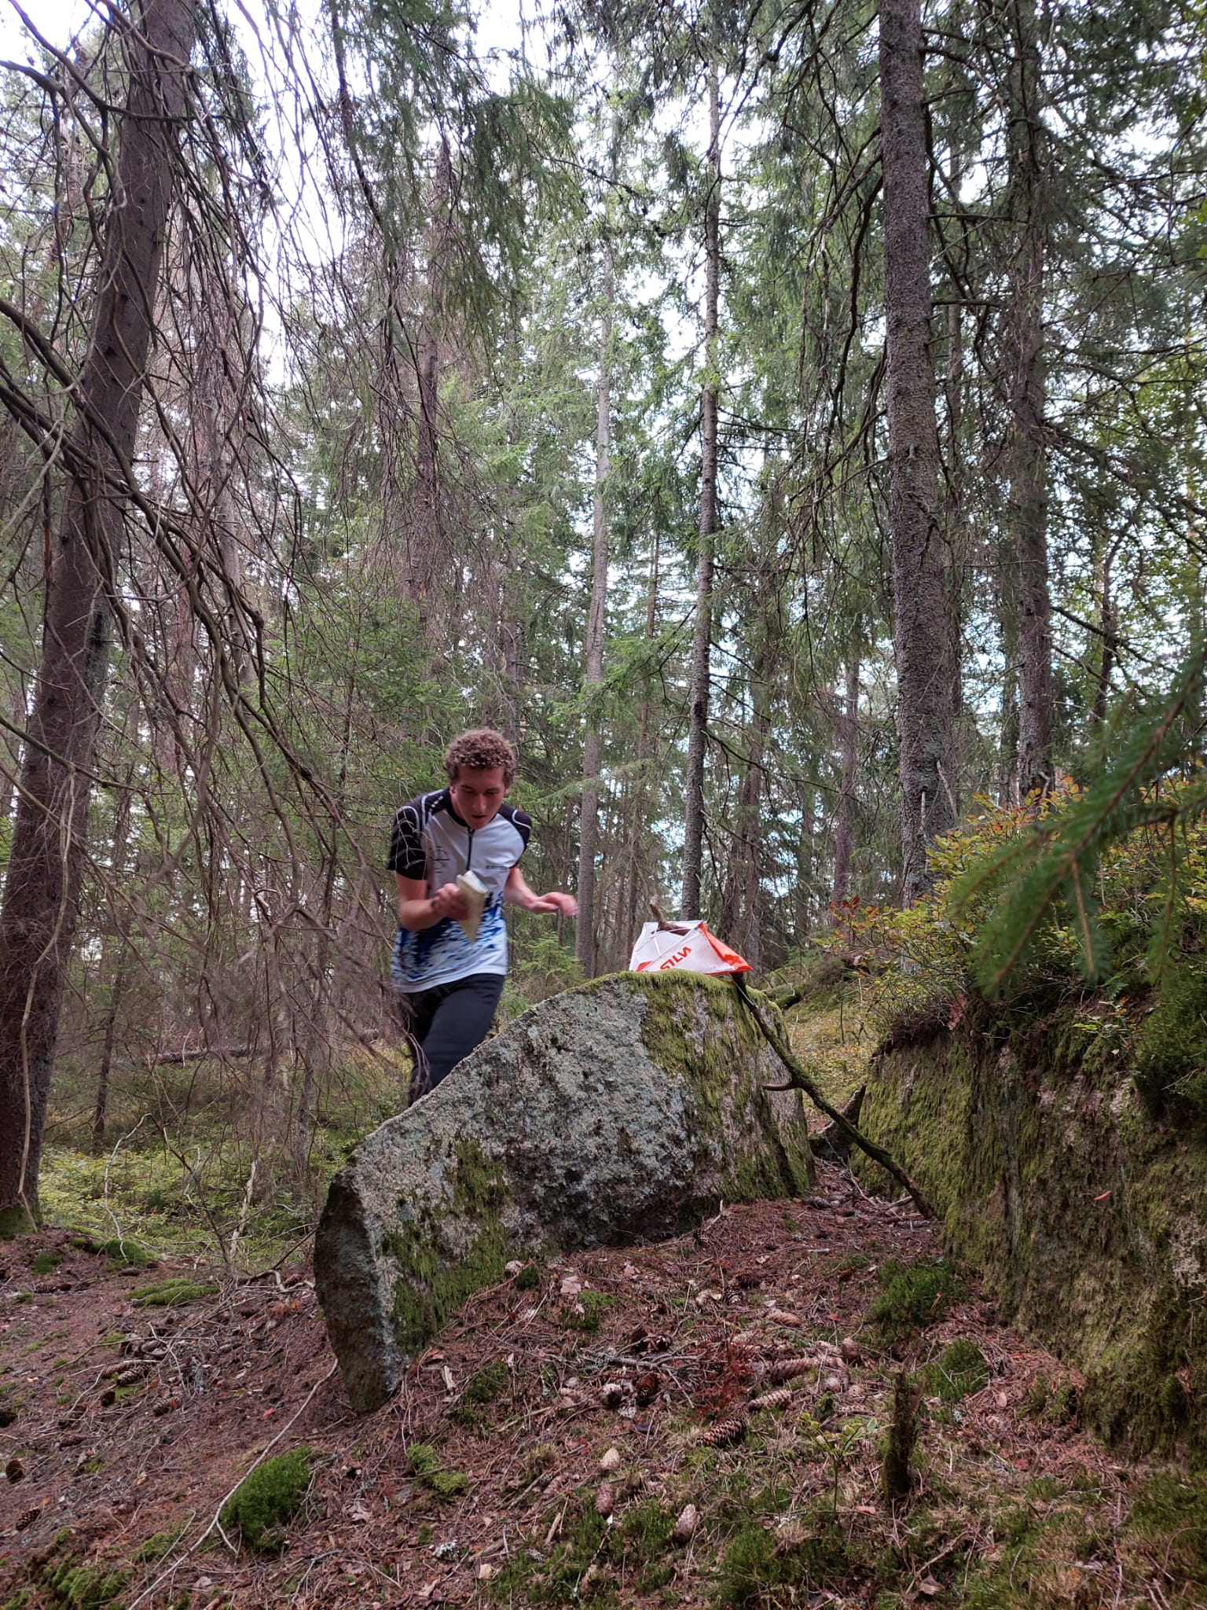
Peter at his first control at the tour champs
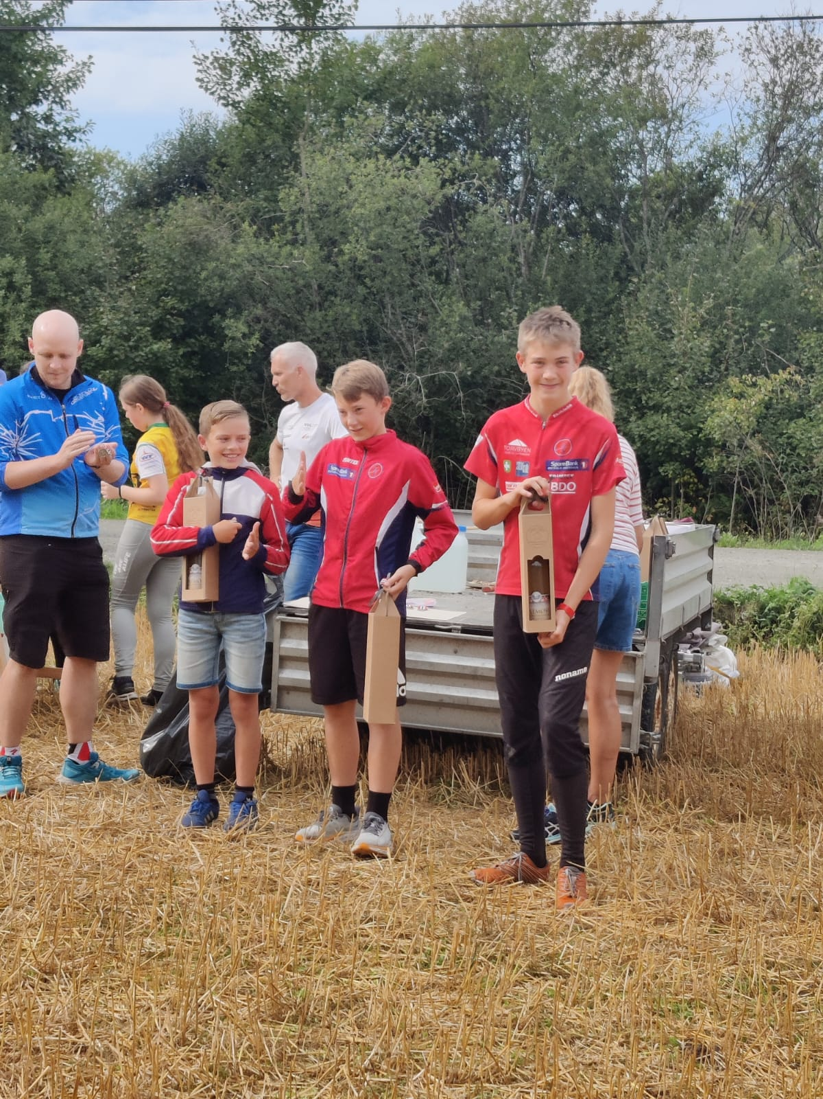
Sam with 2nd place at the middle race – with his “bottle”
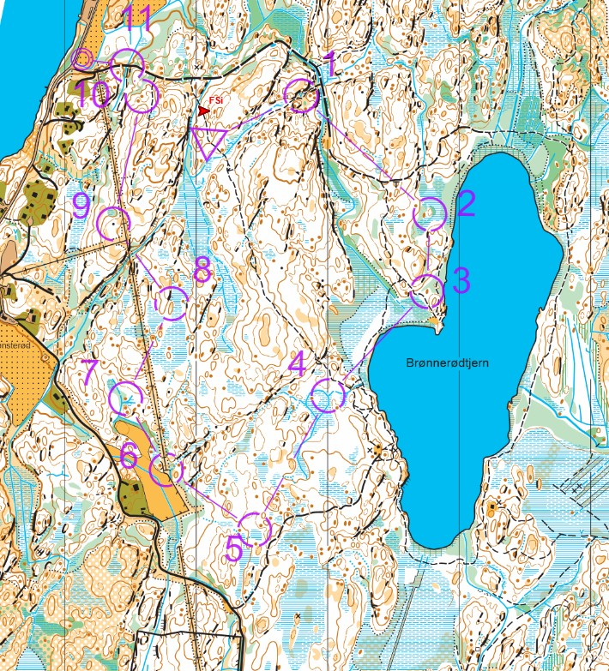
Sam’s middle course
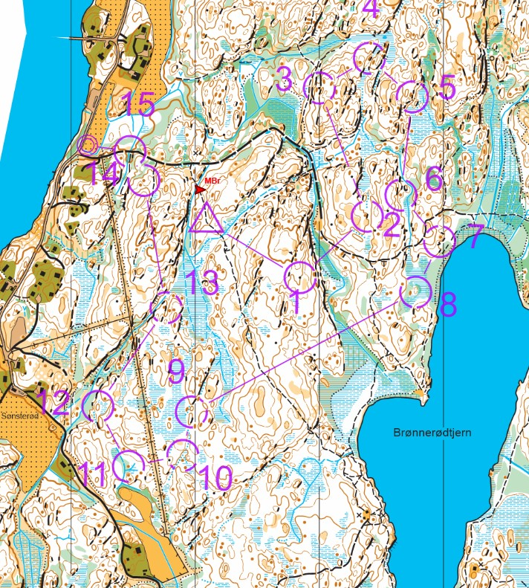
Amelia’s middle course
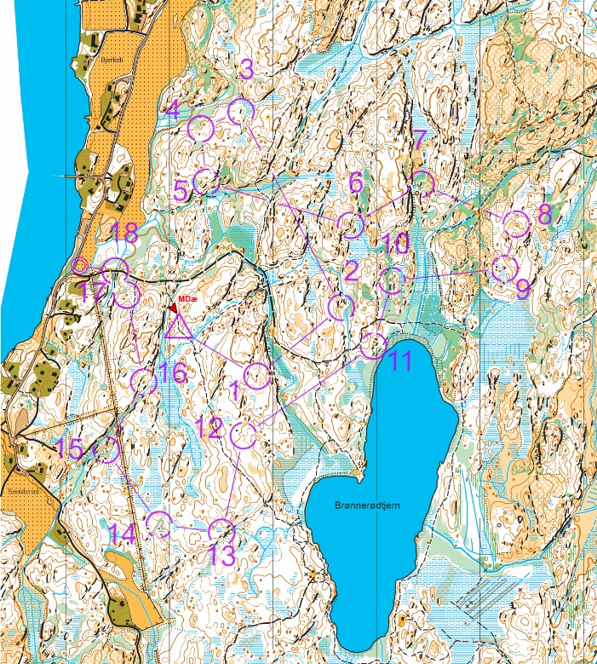
Peter’s middle course.
Peter was “just” beaten by Norwegian world champs runner Magne Daehli.

Sam Osborne
We started the week with 4 day's training around the Skihytte and the surrounding area where the local club "Fredrikstad SK" had done their training in the previous weeks.

Halfway through the week on Wednesday we had a rest day. This included swimming, volleyball, and then we went to the local supermarket.

The latter part of the week involved a couple of days training and three consecutive days racing which involved tour champs, a middle distance regional race and a relay.

Overall the experience was great, and I learned a lot. I hope I can get the chance to do it in two years’ time and do some more orienteering.

I have attached a few pictures from throughout the week.

The first picture attached is part of the area around the Skihytte.

The second is one of the days where we were orienteering on a section which involved a bit of swim-o

The third is a video of the mass start on Tuesday. 16s (+14s?)

PS: A huge thank you to all LOC coaches and also to the club for help funding the trip. It is very much appreciated.
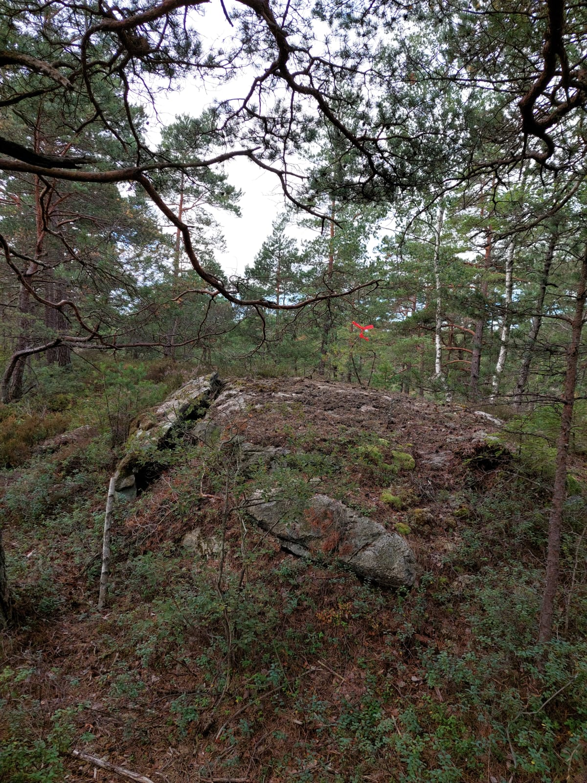
Fredrikstad Skog
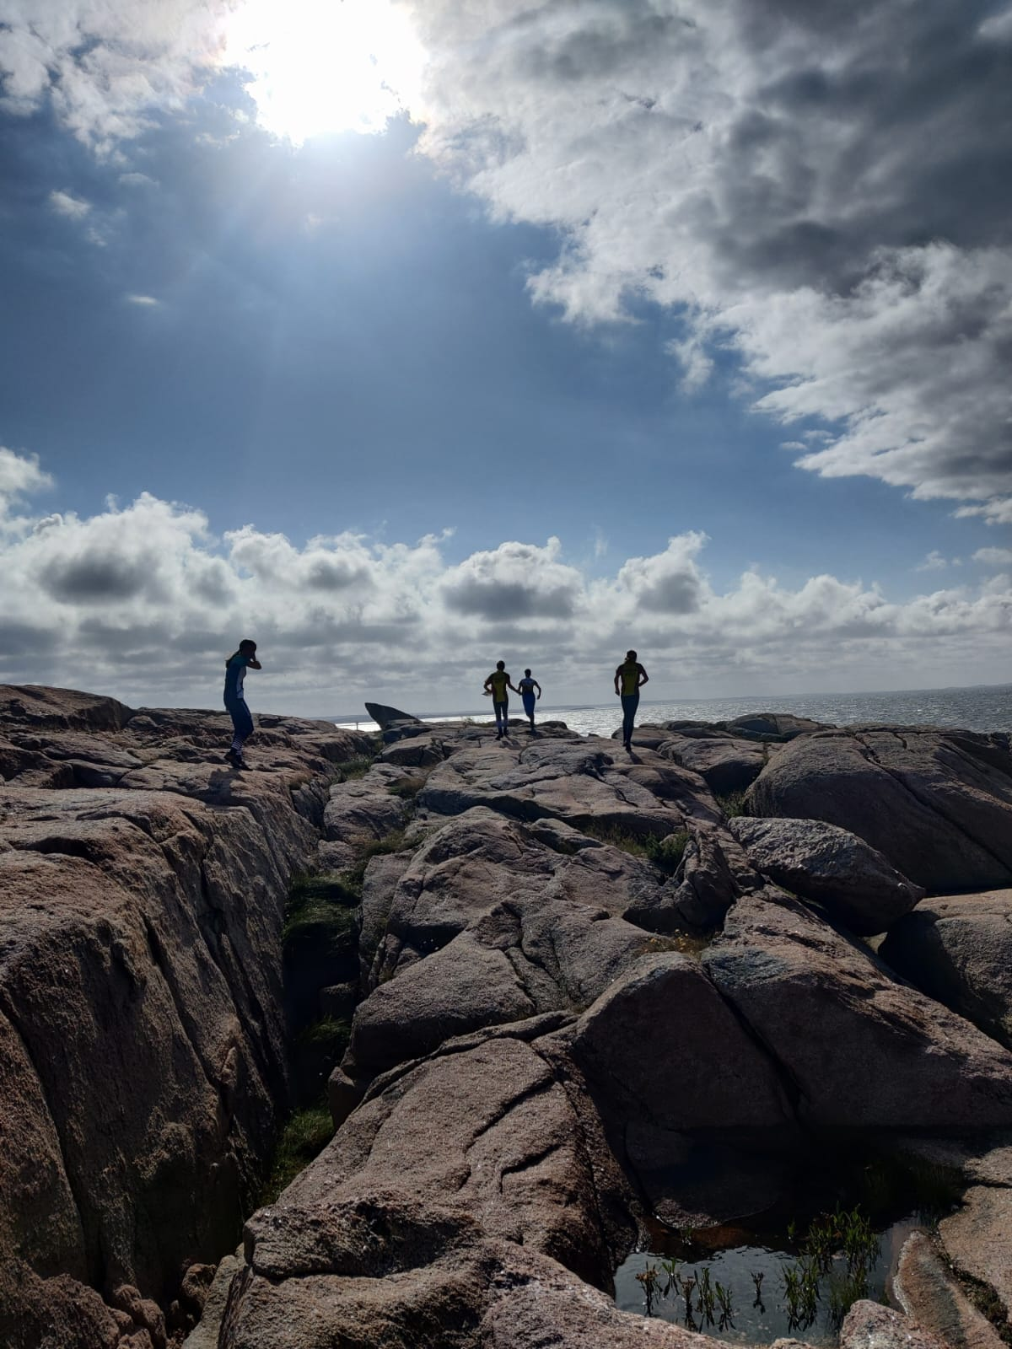
Coastal Orienteering
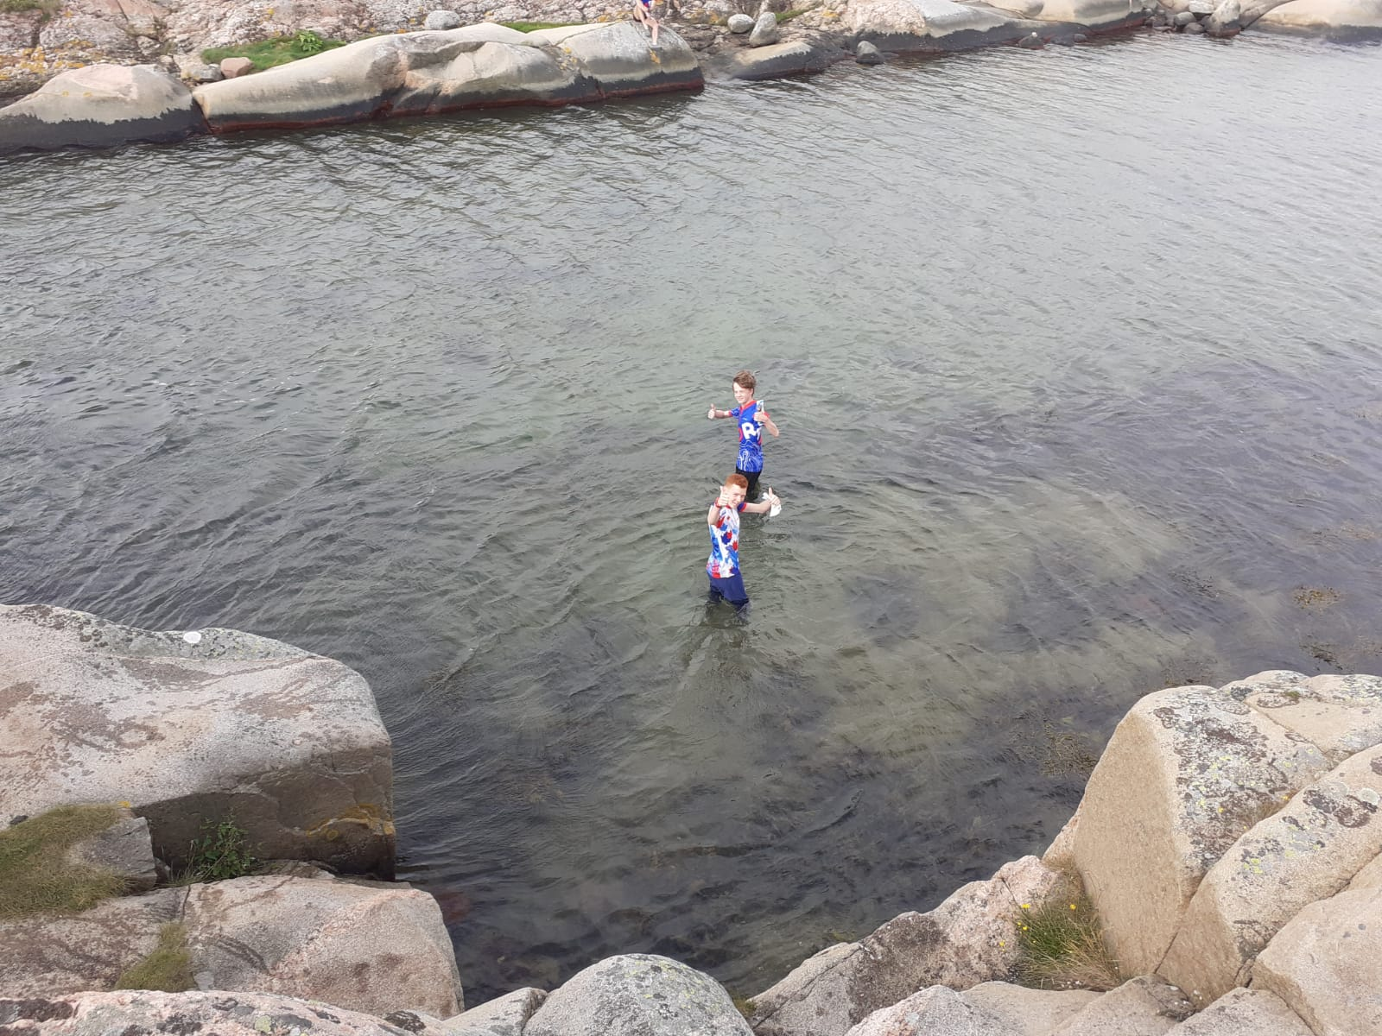
Swim-O

Peter Scott
Looking back on our trip, it was probably one of the best 10 days of my life. The different landscape and culture were quite incredible.

My favourite area was called Viker, which is on the side of a fjord. It was bare rock, with very limited vegetation, meaning it was very runnable, while being challenging to navigate due to gullies across the area which were hard to cross in places. What made it stand out was the course taking you on a swim across the sea to a small island. We were also blessed with a heavy rain shower, which if anything enhanced the dramatic view over the sea.

We stayed in an old wooden SkiHytta, in the middle of a forest, which was amazing for orienteering, and going moose hunting!! Which would be better named snake, or frog hunting as that was all we managed to find.

The racing was a great experience, including the mass starts. It was great to be part of a team, cheering on the rest of the NWJS group as everyone ran in to the finishes.

Thanks to all of the coaches & others who helped make this trip happen.

